**Operating System Lab Project**

**OS Simulator**



**Session: 2021**

**Submitted by:**

**Muhammad Hasnain 2021-SE-07**

**Labeeb Tariq 2021-SE-15**

**Wali Muhammad 2021-SE-39**

**Noman Danish 2021-SE-49**

**Sameer Ahmad 2021-SE-54**

**Submitted to:**

**Mr. Waqas Ali**

Department of Computer Science, New Campus

**University of Engineering and Technology Lahore, Pakistan**

Table of Contents

Introduction of Operating System Simulator **Error! Bookmark not defined.**

Project Requirements **Error! Bookmark not defined.**

1. Project Description **Error! Bookmark not defined.**
2. Project required working **Error! Bookmark not defined.**

Compulsory Tasks Description **Error! Bookmark not defined.**

Optional Tasks Description **Error! Bookmark not defined.**

Additional Feature **Error! Bookmark not defined.**

Guide **Error! Bookmark not defined.**

Concepts used

**Error! Bookmark not defined.**

1. **Introduction to Operating System Simulator**

An OS simulator is a computer program that emulates the behavior of an operating system. It allows users to interact with an operating system in a simulated environment, without the need for actual hardware or physical resources. Users can explore the functionality of an operating system, perform tasks, and learn about various operating system concepts such as process scheduling, hardware resources allocation, process creation and threading.

In this project, we have created an OS simulator that demonstrates various OS concepts that were taught us in Classroom as well as in Lab, such as multitasking, resource allocation, user mode and kernel mode, process creation, threads, and scheduling techniques, pipes, semaphore, and condition variable. Our OS simulator also includes a queue that is used for process scheduling which has different techniques applied to each level, enabling users to prioritize and execute various tasks in an efficient and organized manner.

The project is implemented in C and C++ programming languages. we used both C and C++ to develop the various components of the system, including the hardware resource allocation, process creation, scheduling, and the compulsory and optional tasks. The efficient and low-level nature of C made it a good choice for handling hardware resources, while the object-oriented features of C++ helped us organize and manage the various tasks and processes within the system.

1. **Project Requirements**

The project is created as per requirements provided by our instructor. A brief information of the Project Requirements are given below for better understanding.

1. **Project Description**

An operating system (OS) is system software that manages computer hardware,

software resources, and provides common services for computer programs. In this

project you will design a simulation of operating system on your own. The simulation should be made using and following all concepts studied in this course.

**Key features the operating system should have:**

* Your operating system should have a name of its own that will display on starting the program

Detail: You should make the program in such a way that when it starts it

displays the name of your operating system on terminal using sleep command

for some seconds like it is loading.

* The RAM hard drive and the number of cores will be given by the user while starting the OS.
* This instance of OS will have 8GB RAM, 256GB Hard drive and 2 cores you can choose your own convention.
* The resources should be managed in you operating system RAM Hard drive and cores should be kept in mind while making new processes or threads.
* You will define basic applications and tasks that your operating system can

perform Basic tasks would be like Notepad (writing into file with auto save

function), Calculator, Time, creating a file, Move, Copy, Delete file,

Check file info, Minigames (minesweeper etc.)

* You should have minimum of 15 tasks in your operating system

Detail: Each task should have a defined task its own separate code file and it

should make a new process simple function calling is strictly not allowed the

once a process is created it will send the creating process message that will

contain memory required in Hard drive and RAM if available then the process

will reply grantee else the process should be terminated each process will have

its own terminal so the output is not messed up.

This will help you to enable multi-tasking in your operating system.

* You can also manually create an interruption to stop the specific task or

minimize it.

Detail: Each task should have a button to close the task in between so to make

a simulation of interrupt.

* Your operating system should be able to multitask.
* Your operating system would have user mode and kernel mode (in kernel mode you can access hardware resources)

Detail: In kernel Mode user can close or delete the processes from memory

meaning you can close running programs

1. **Project required working**

You will provide Hardware resources on starting program. The operating system

will start and its name will be written on boot screen. After starting some basic

tasks like time and calendar should start on their own you can also add other tasks

on startup. An instruction guide should show all the tasks a user can perform in

your operating system. The user can then select a specific task and it should start

working in a new terminal for that you can use EXEC commands. It will take

specific location and size in RAM and wait for its turn to execute which will be

controlled by you using scheduling techniques if the processes increase the total

number of cores you need to schedule the processes. If the user starts any other

program that will be added into the RAM too. A ready queue will schedule all

the tasks in the RAM on its own and send them for processing. If any interrupt

for input in task or some other external interrupt occurs the task should move into

blocked section. For that time processor can process some other tasks. After the

interrupt for first program ends it can execute again. Each process will execute

according to its turnaround time which will be set during coding. User will not

provide this on runtime. After task is completed, it should be removed from the

RAM. If user saves something it should be saved in the hard disk.

1. **Compulsory Tasks**

Here is the list of 10 Compulsory Tasks that were provided by instructor as per requirement of the project.

* Notepad
* Calculator
* Time
* Creating a file
* Move file
* Copy file
* Delete file
* Check file info
* Image viewer
* Text editor

1. **Optional Tasks**

The list of Optional tasks were also provided along with the Compulsory tasks. Every group had to choose 5 from them. Here is the list of the Optional Tasks that we added to our OS Simulator as per requirement of the project.

* Hangman Game
* Snake Game
* Task manager
* Huffman text encryption
* Huffman text decryption

1. **Additional Feature**

In addition to the standard OS simulator tasks, we have added a new feature that is simple command line interface. Although this was provided as an Optional task but we have worked a little on this task and we have created a Custom Linux Shell. The detail required to this additional feature or functionality is given below:

1. **Introduction to Linux Shell**

The shell can be defined as a Command Interpreter within an operating system like Linux/GNU or UNIX. A program, which runs other programs. The shell facilitates every user of the computer as an interface to the Unix/GNU Linux system. Hence, the user can execute different tools/utilities or commands with a few input data. The shell sends the result to the user over the screen when it has completed running a program, which is the common output device. That is why it is known as "Command Interpreter”.

1. **Diagram of Linux Shell Structure**

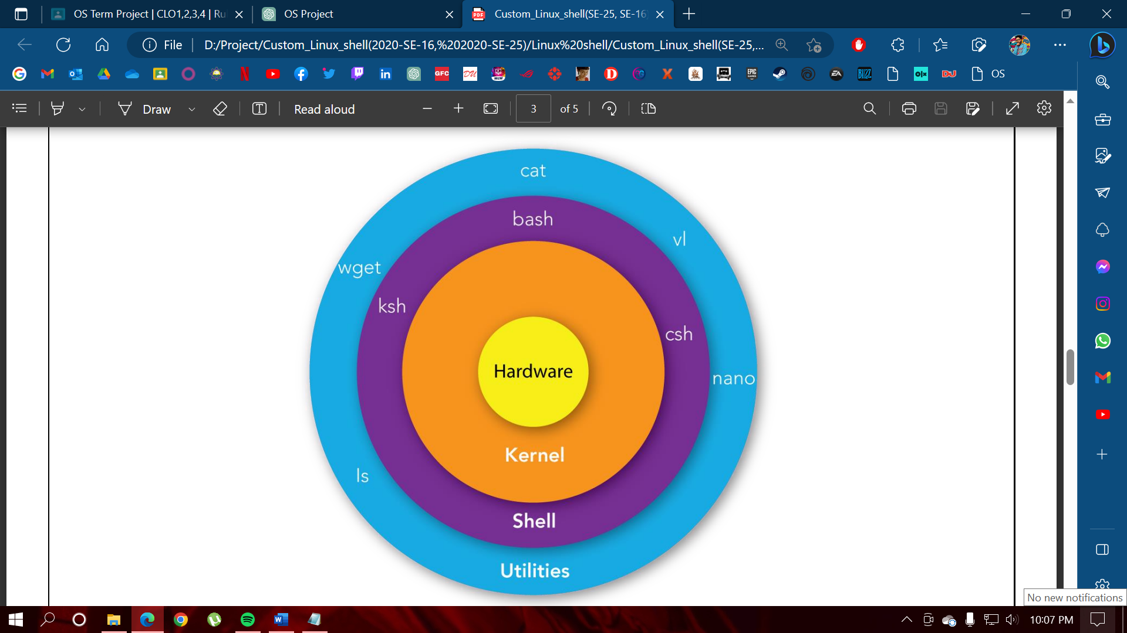

1. **Mian Feature**

We have tried to implement the following features in our project:

1. Providing menu-driven interface to execute Commands relevant to its number.
2. Different colors are used to fascinate user experience.
3. Arguments of Commands are taken from user using interactive prompt message.
4. Shortcut key is also provided to execute the Shell interface from any location/directory.
5. Provide useful description of errors.

6. Provide abstract-level help i.e., definition about implemented Commands.

1. **Core Concepts Used**

We have tried to implement and use the following core-concepts in our project:

1. Core C-language programming concepts like Dynamic-memory allocation, Functions, Pointers, Macros, Loops, etc.
2. Process-Child creation (Fork).
3. Executing an executable file from a C-program using execv() system call.
4. String tokenization.

**6. Guide**

The guide to use Operating System is provided with execution screenshots below:

1. **Working**

The working the project is as per required so we are demonstrating the steps to run the Simulator below.

1. **Starting execution of Simulator**

To start the project, we first have to open Ubuntu in our Virtualization software (etc. Virtual Box, VMware Player). In our case we are working on VMware Player Workstation 16. After opening the Ubuntu, we have to open terminal in order to start execution of our project. The steps to execute the OS Simulator are given below with the screenshots.

**Steps:**

* After that, we have to enter the Hardware Resources as command line arguments as per required in the Project Description.

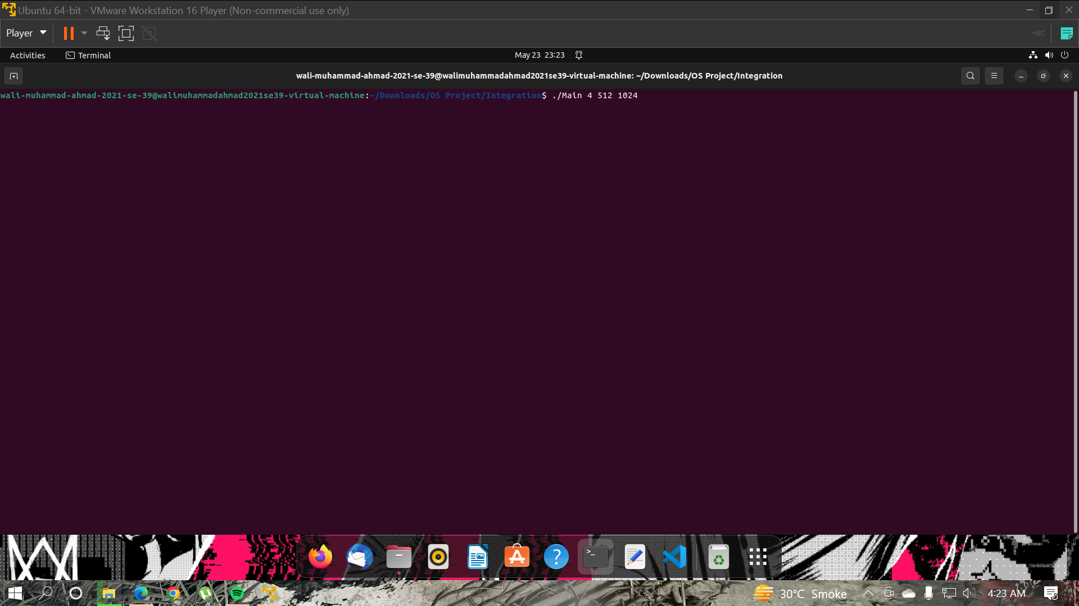

* The Name of the OS Simulator “BeserkerOS” is displayed along with allocated hardware and Loading screen. This will take almost 100ms to show this in terminal.

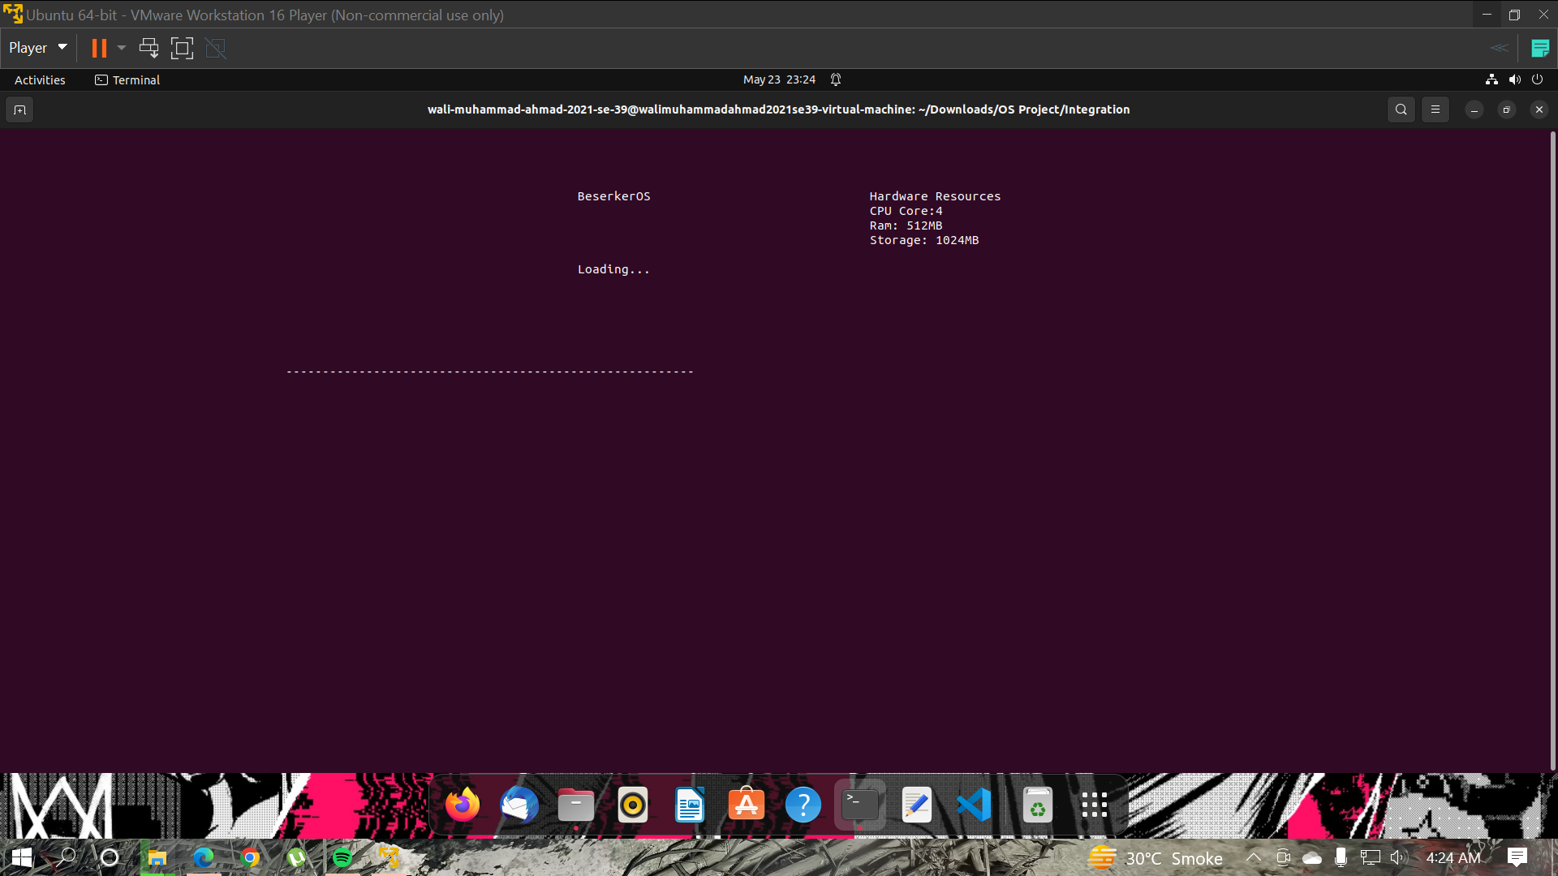

* After the output there is a Menu for the user to select tasks. Use have to use the arrow up and arrow down keys to select the desire tasks that user wants to run next. After selecting the Option with arrow keys, the user must hit enter to start the task.

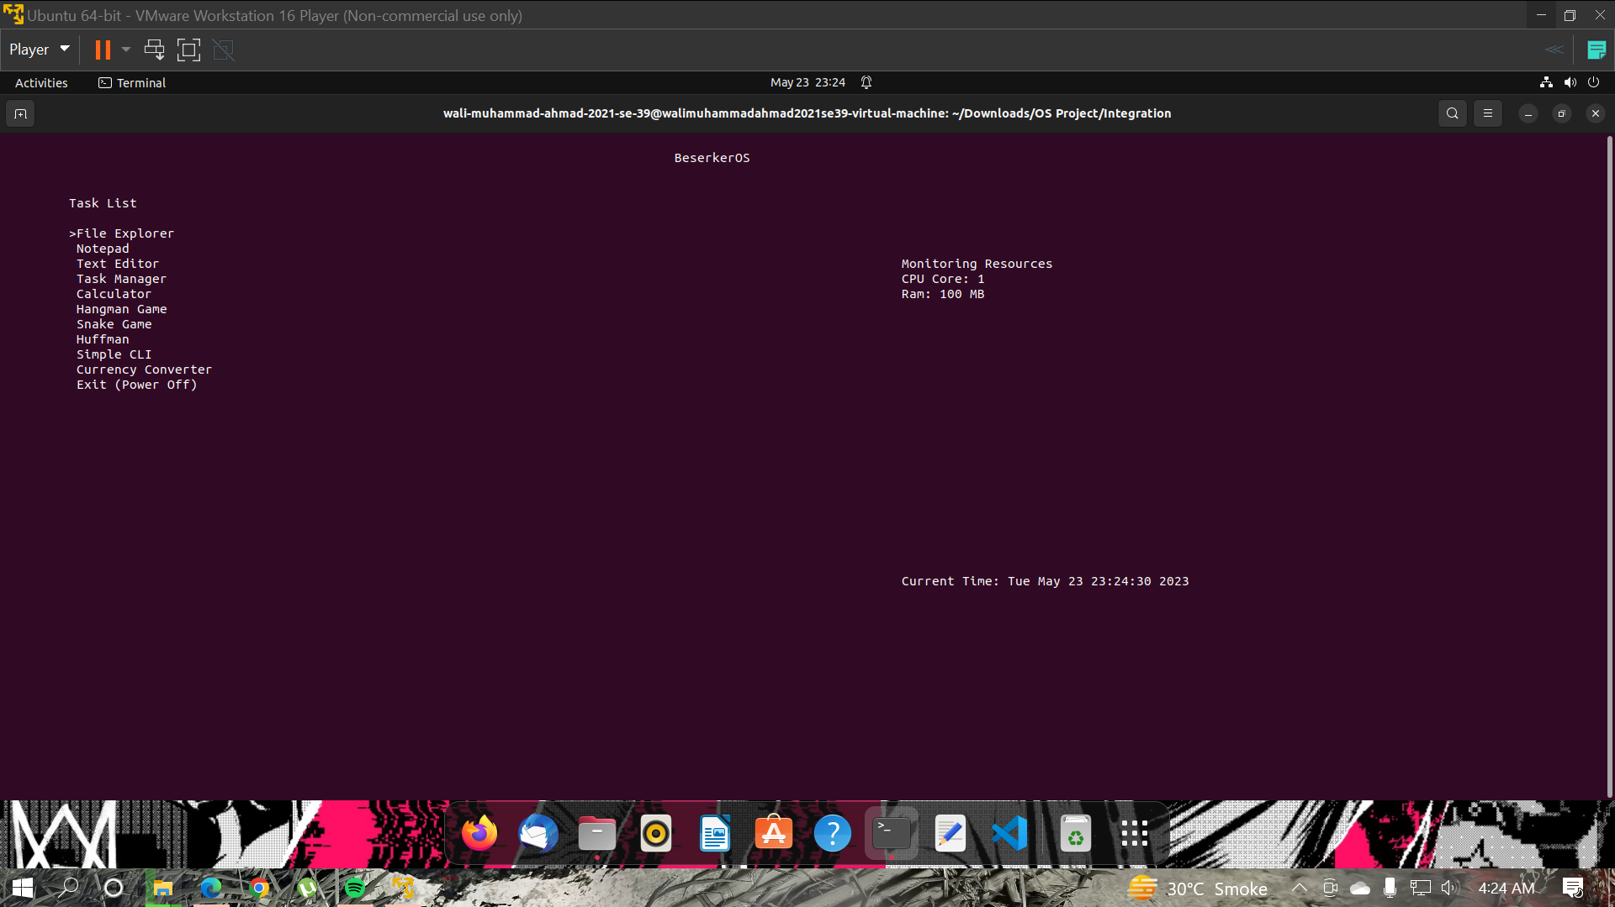

1. **File Explorer**

* There an option named File Explorer that contains sub-tasks like Copy files, move file, delete files etc. These options will be open in new terminal. To run the task, you have to first enter the name of the task as it is given in File Explorer. The Screenshots are provided below how to perform specific tasks in File Explorer. Follow the screenshots to perform the specific task.

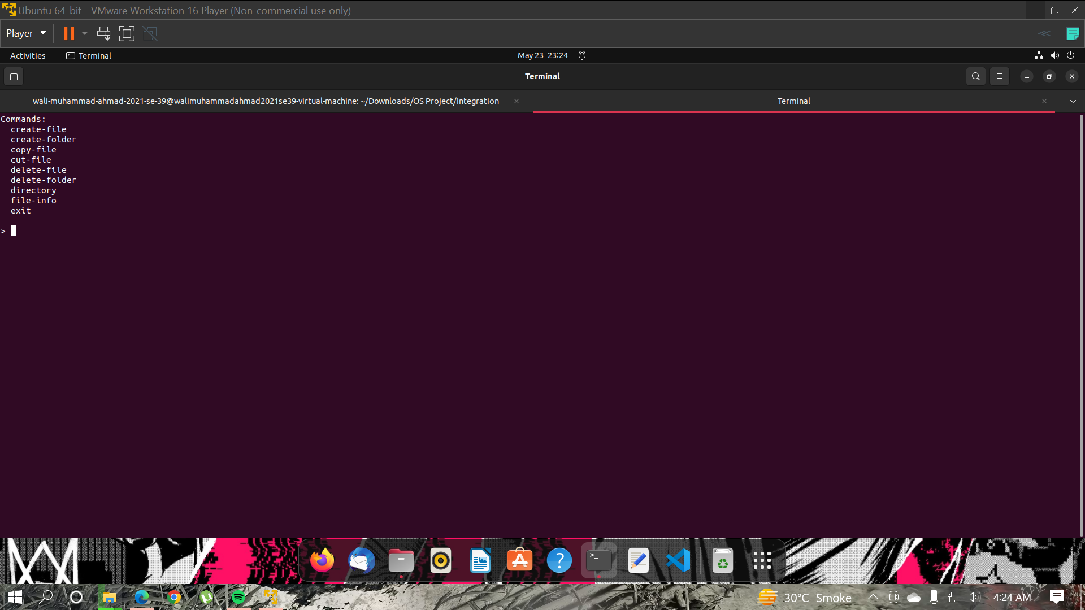

* **create-file/create-folder**

The create-file/create-folder works in same way. User first entered the command create-file and then a tree like directory hirechery will show. After that user have to enter the path. The path name folder should be added same as in the tree shape and then enter ‘q’ to quite entering the path. Then enter the file/folder name to create it.

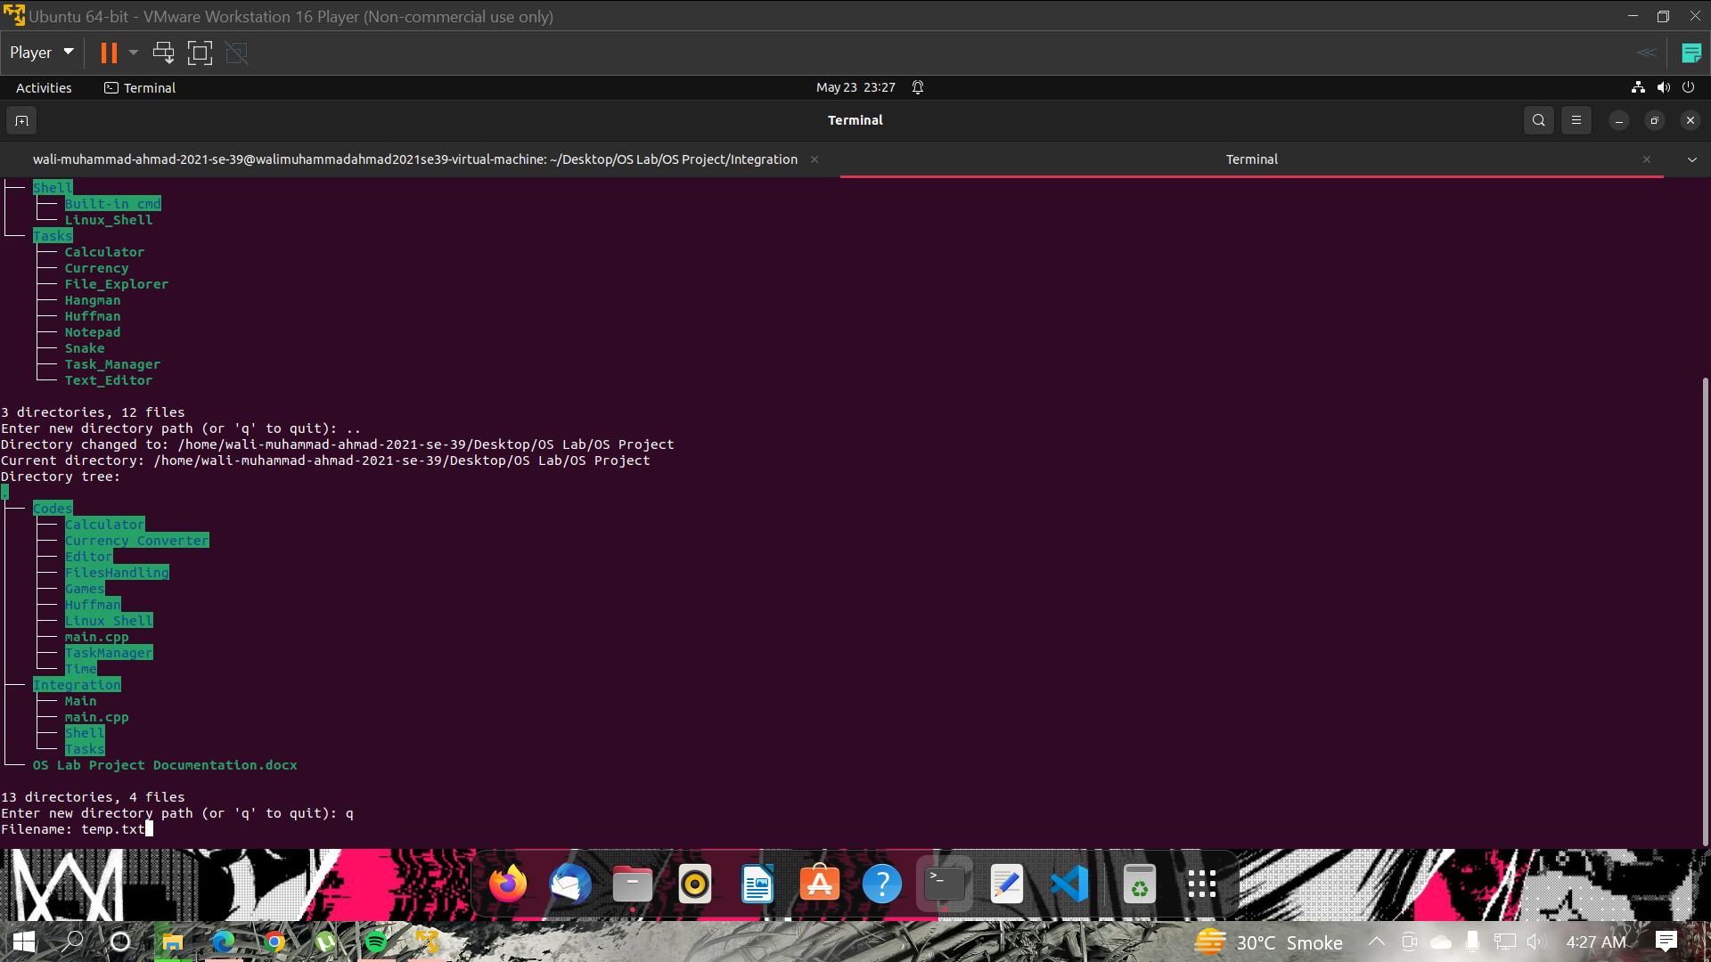

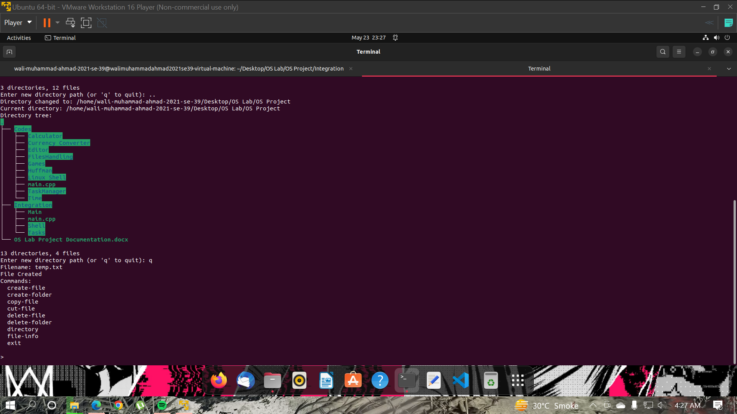

* **copy-file/cut-file**

The copy-file/cut-file works same. User have to enter the path from which he/she wants to copy/cut file. Then enter the name of the file and then enter the path when the user wants to paste the file.

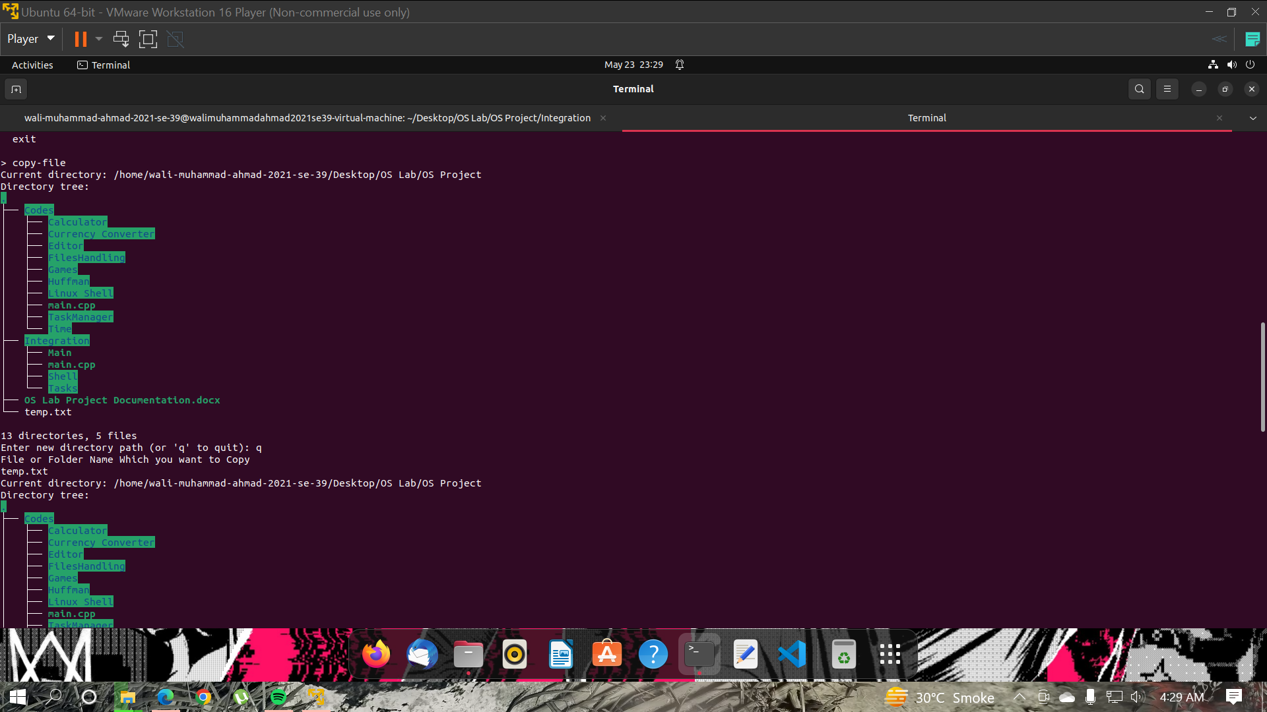

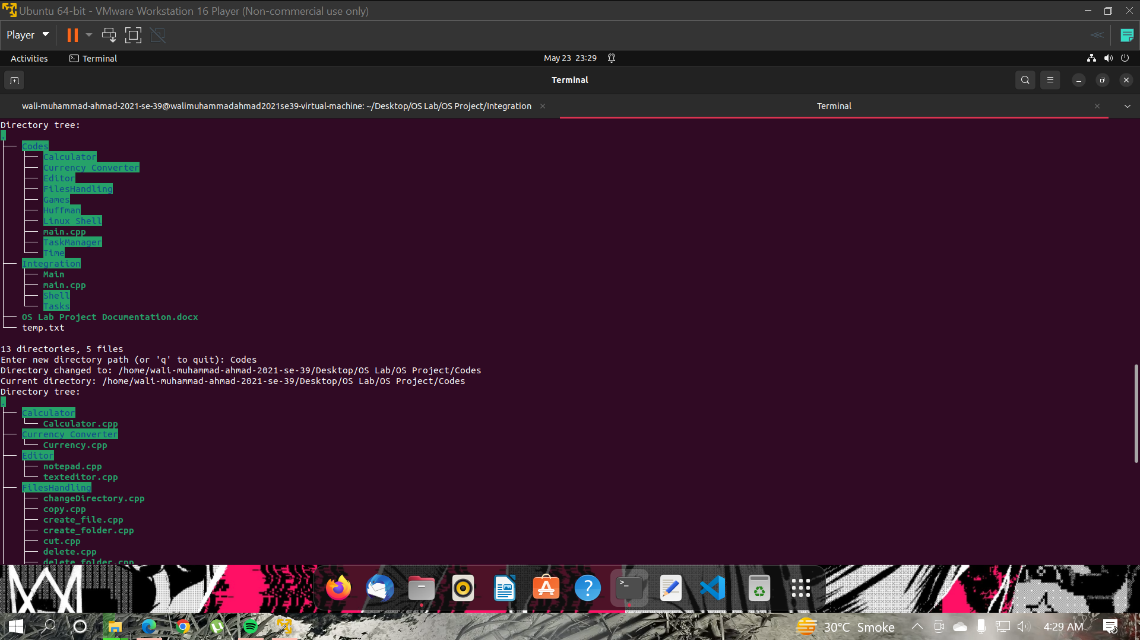

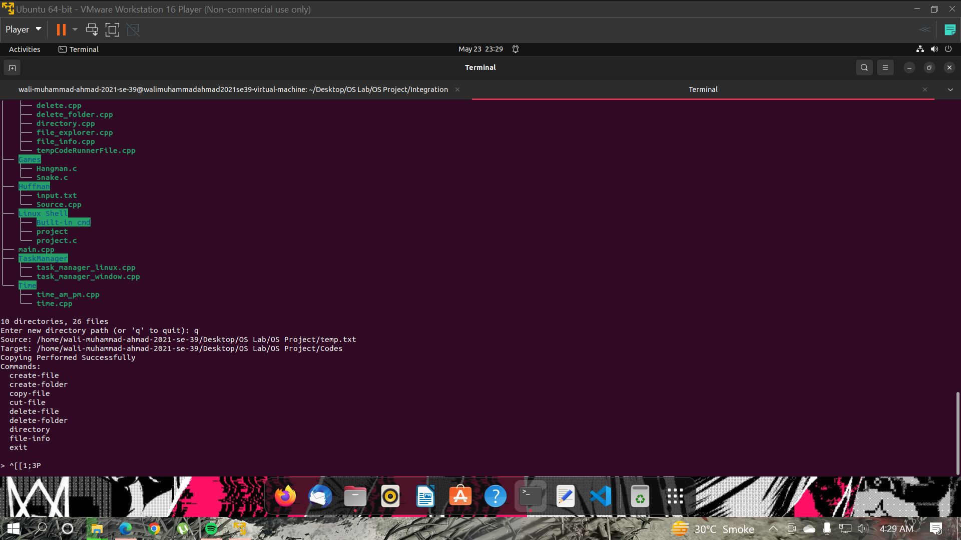

* **delete-file/delete-folder**

The delete-folder/delete-file also works same. The user have to first enter the path and then the file/folder name to delete.

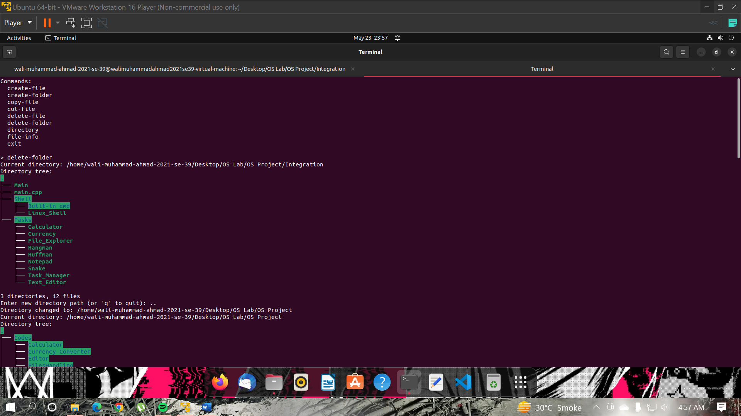

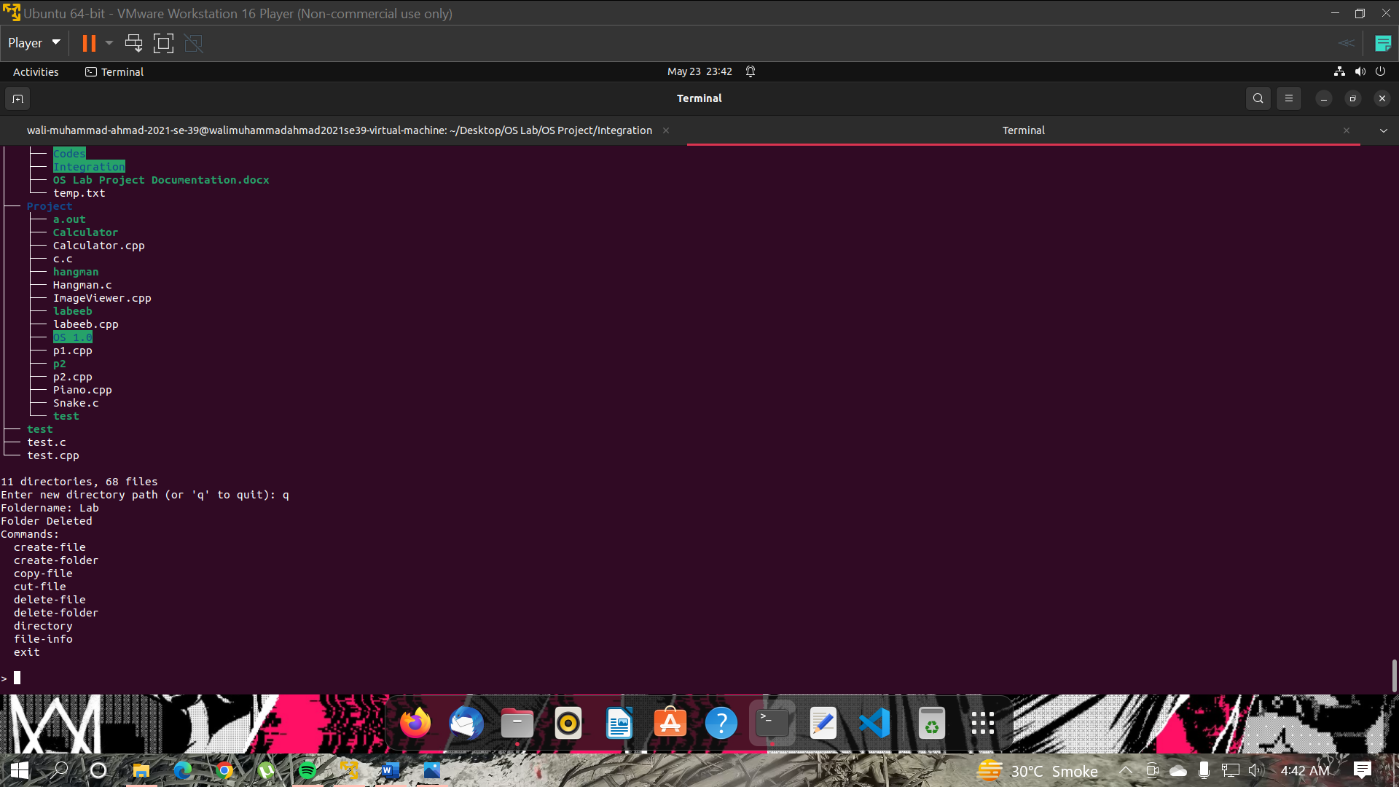

* **directory**

The directory option will show the current location and if there are folders in the current location it will show that you can also move into that folder by entering the path in other options.

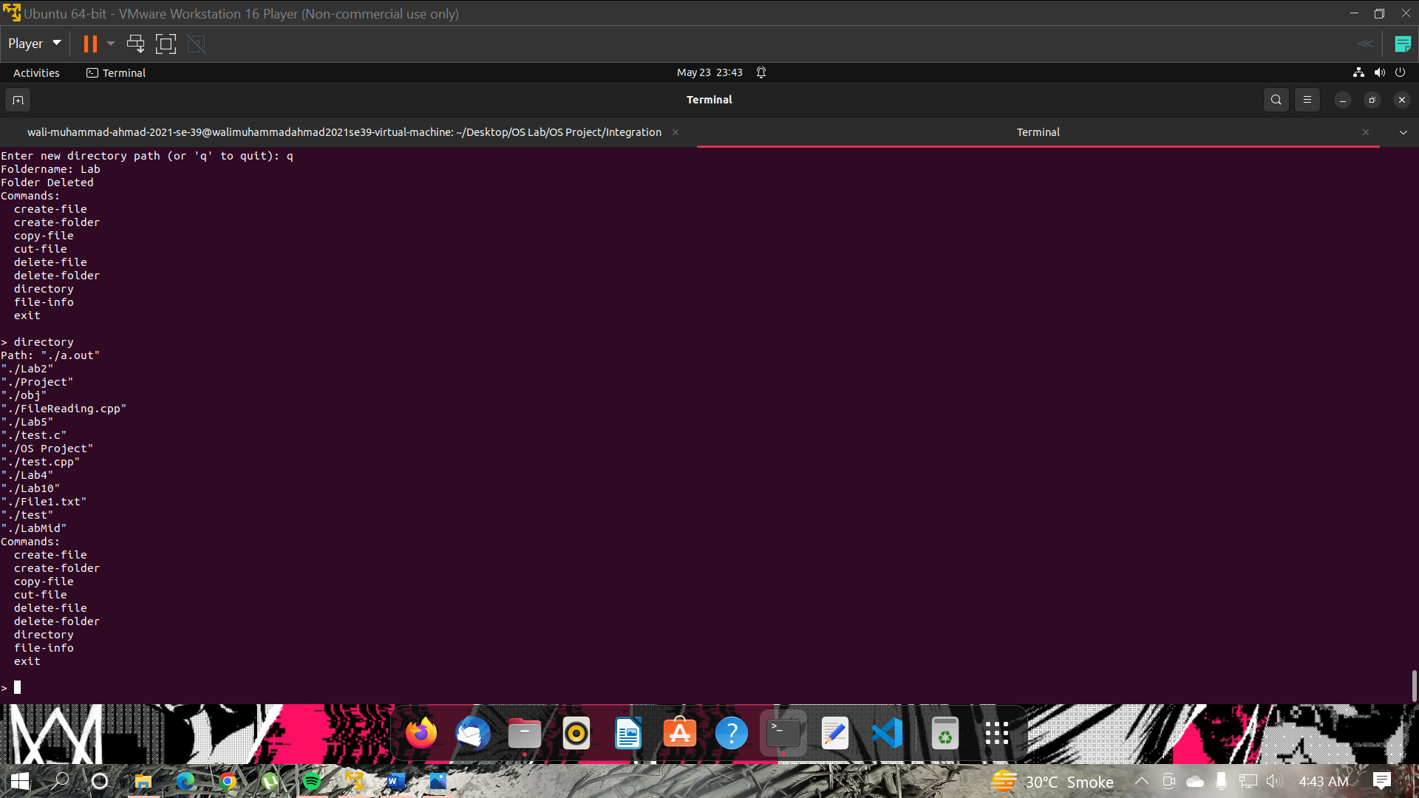

* **file-info**

The file-info firs asks for the path. The user have to enter the path of the file and the user have to enter the file name for which he/she wants to see the info. The complete file-info process will be showing in the screenshot below:

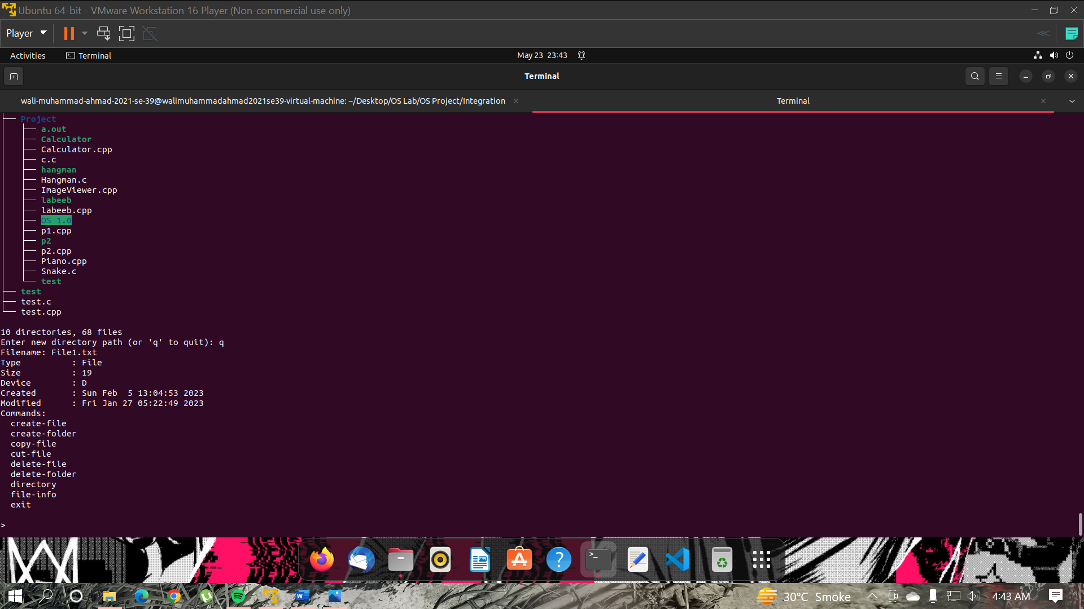

* **exit**

The exit option will simple exits from the File Explorer.

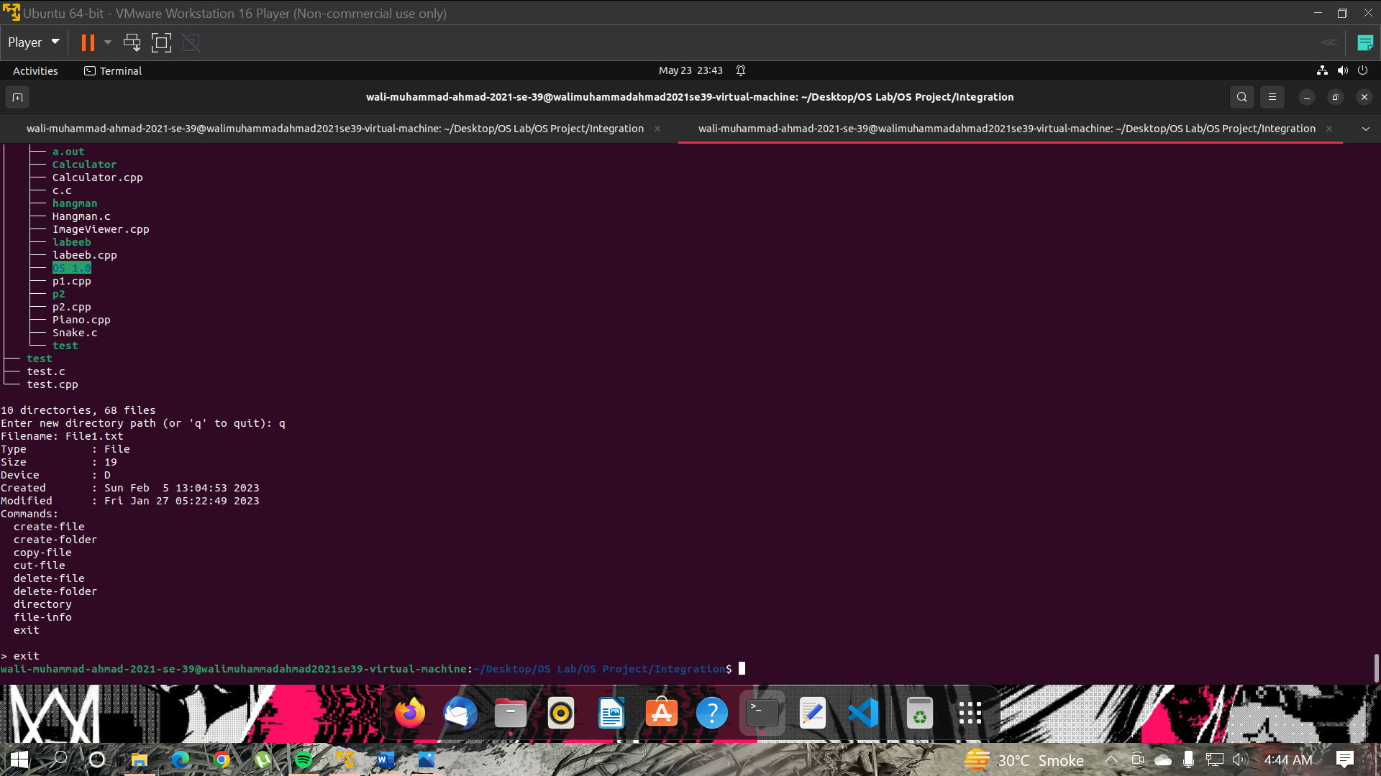

* **Resource allocation**

While the File Explorer was running in the other terminal, the Resource allocation calculate the resource allocated to the file explorer in the main terminal screen. The calculates and shows the allocated resources of every tasks running in the other terminal.

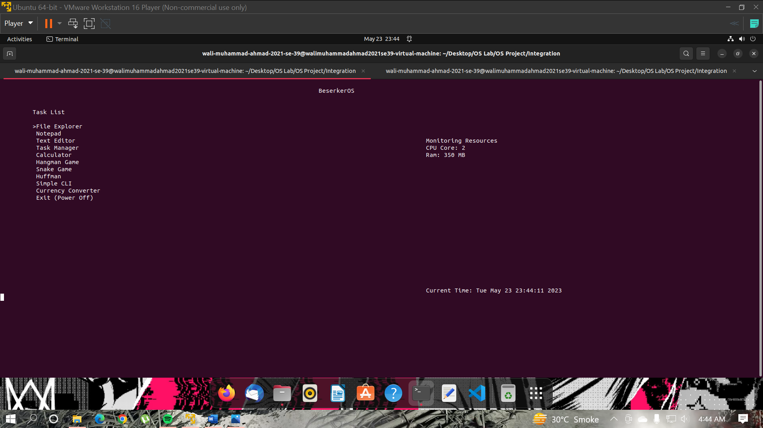

1. **Notepad**

The has the 5 options. The method used in showing in the screenshot provided.

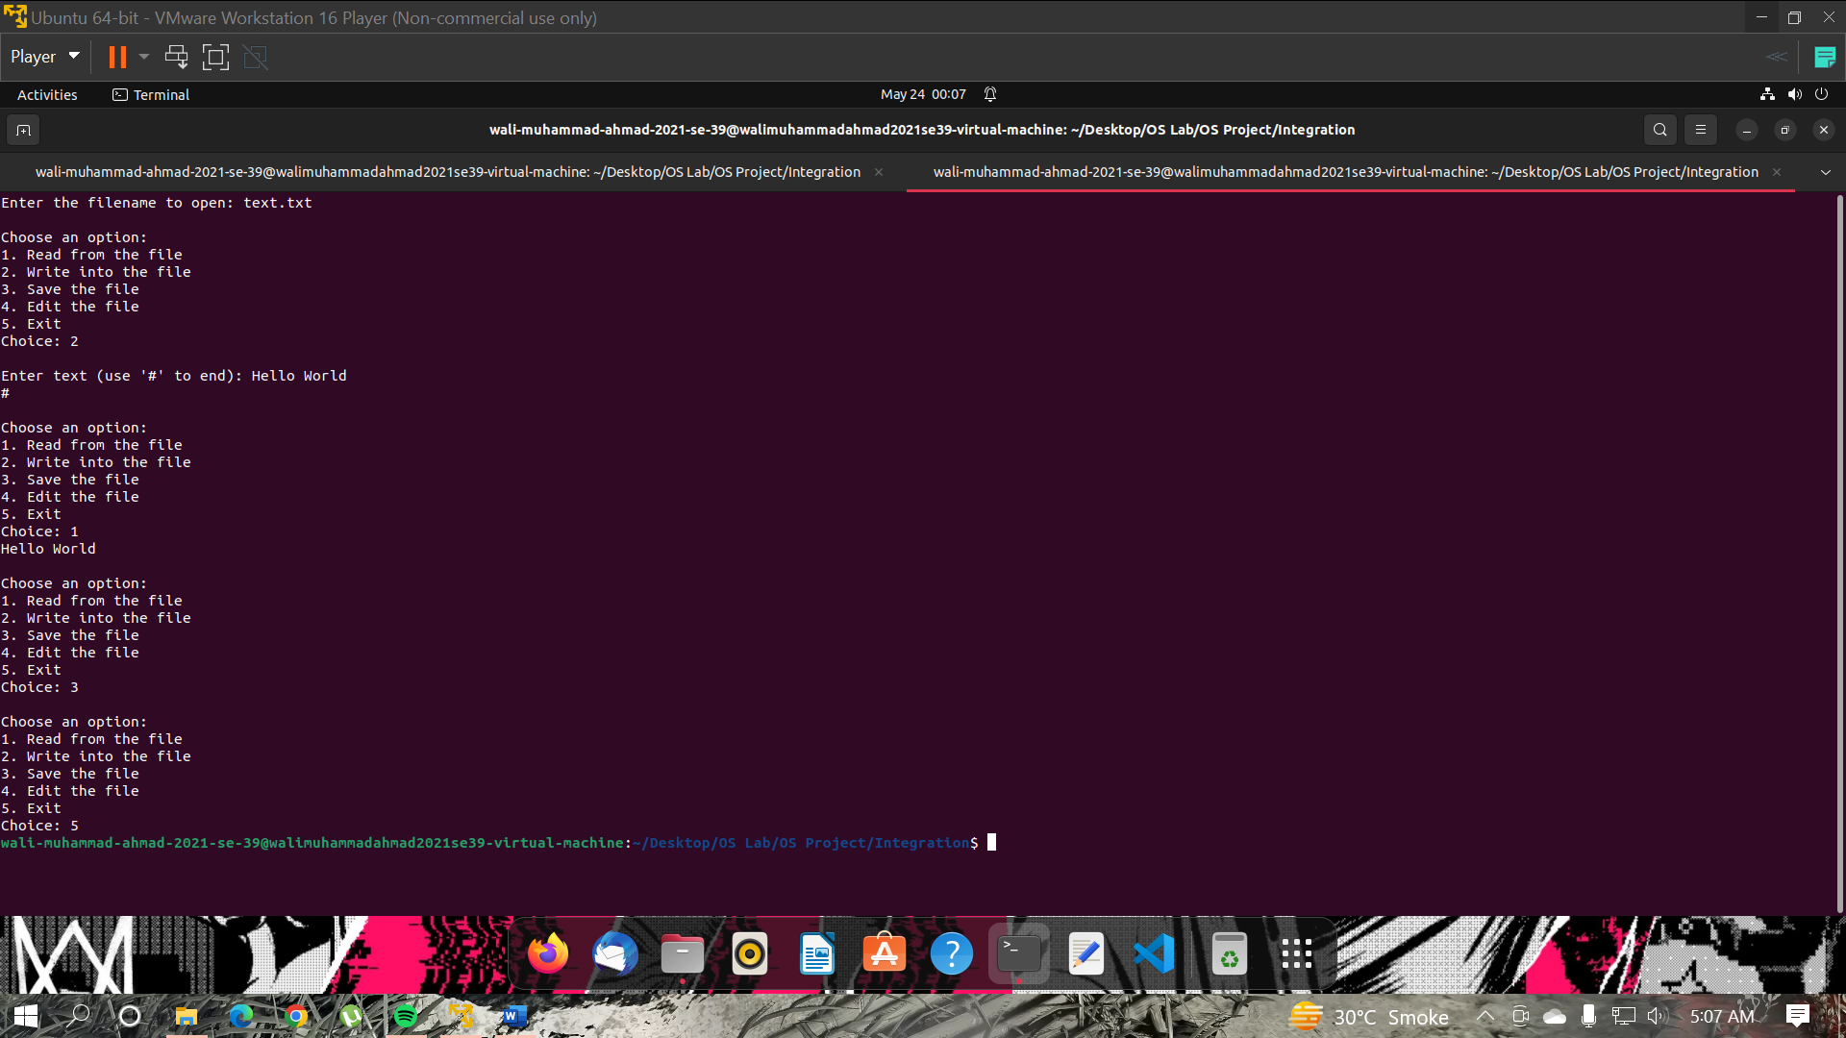

1. **Text Editor**

The method to use Text Editor is shown in the screenshot provided.

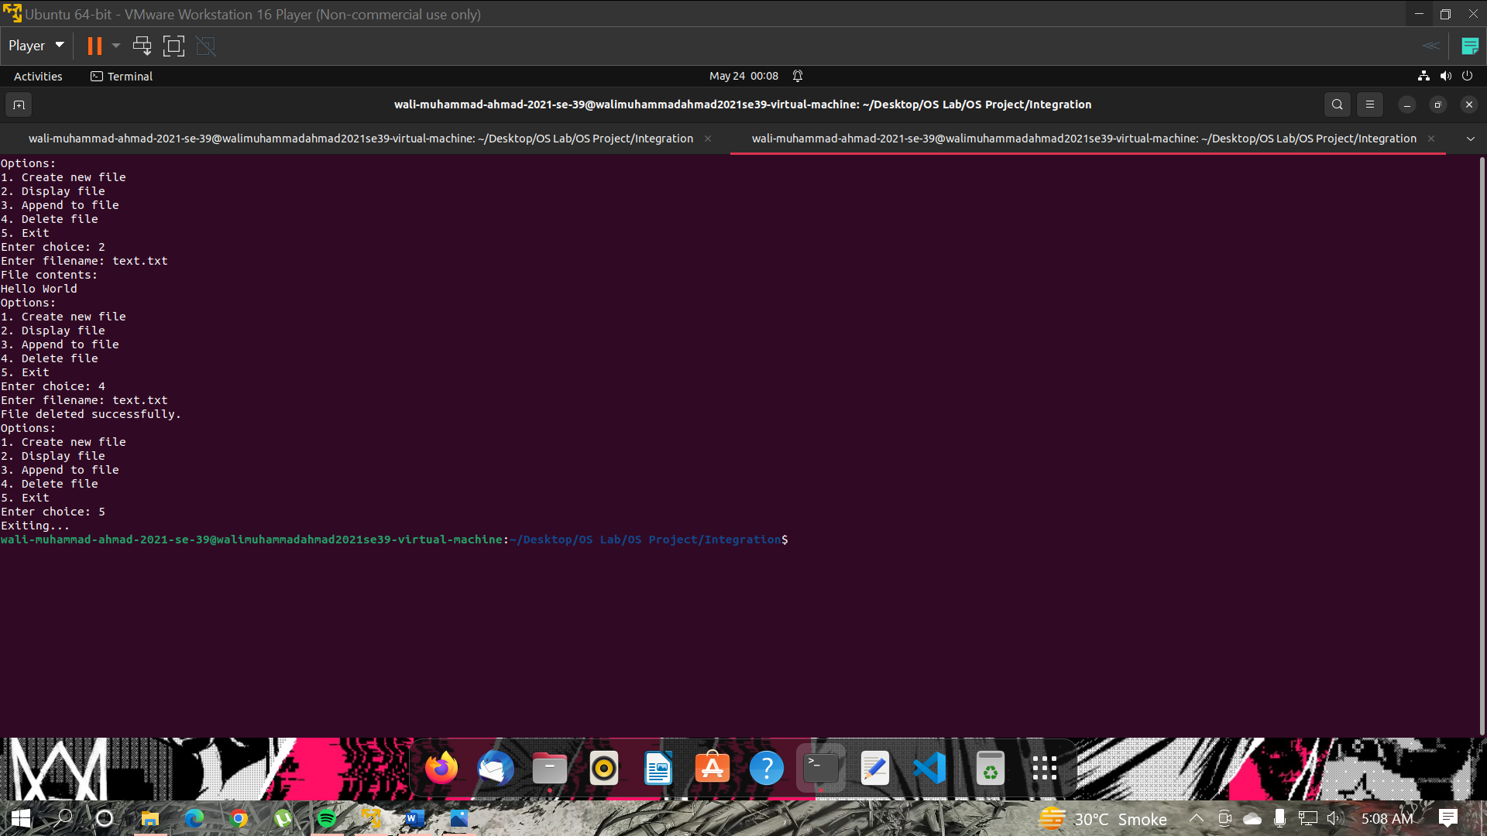

1. **Task Manager**

The method to use Task Manager is shown in the screenshot provided. The Task manager show all the tasks running at the time in the ubuntu. It also shows the tasks that are currently running in the OS Simulator. If the user wants to kill the task running in the OS Simulator, then the user have to enter the process id to terminate/kill the task. Entering the process id of the ubuntu owns process to kill the process can cause terminating of the OS Simulator or Ubuntu itself.

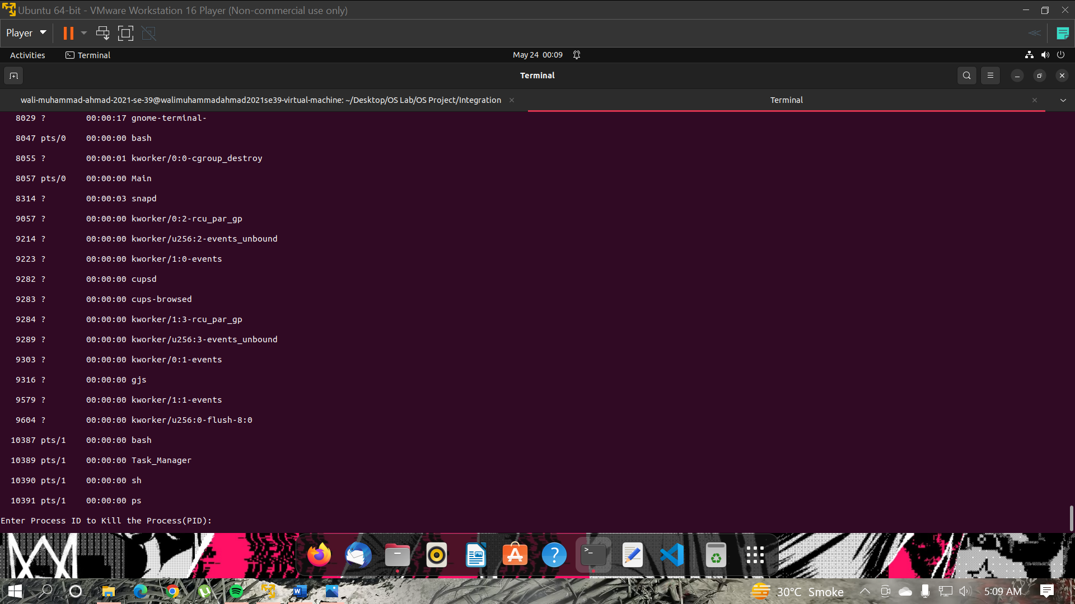

1. **Calculator**

The method to use Calculator is shown in the screenshot provided. In every option the calculator will ask how many variables you want to compute. User have to enter first the number of the variables he/she wants to calculate.

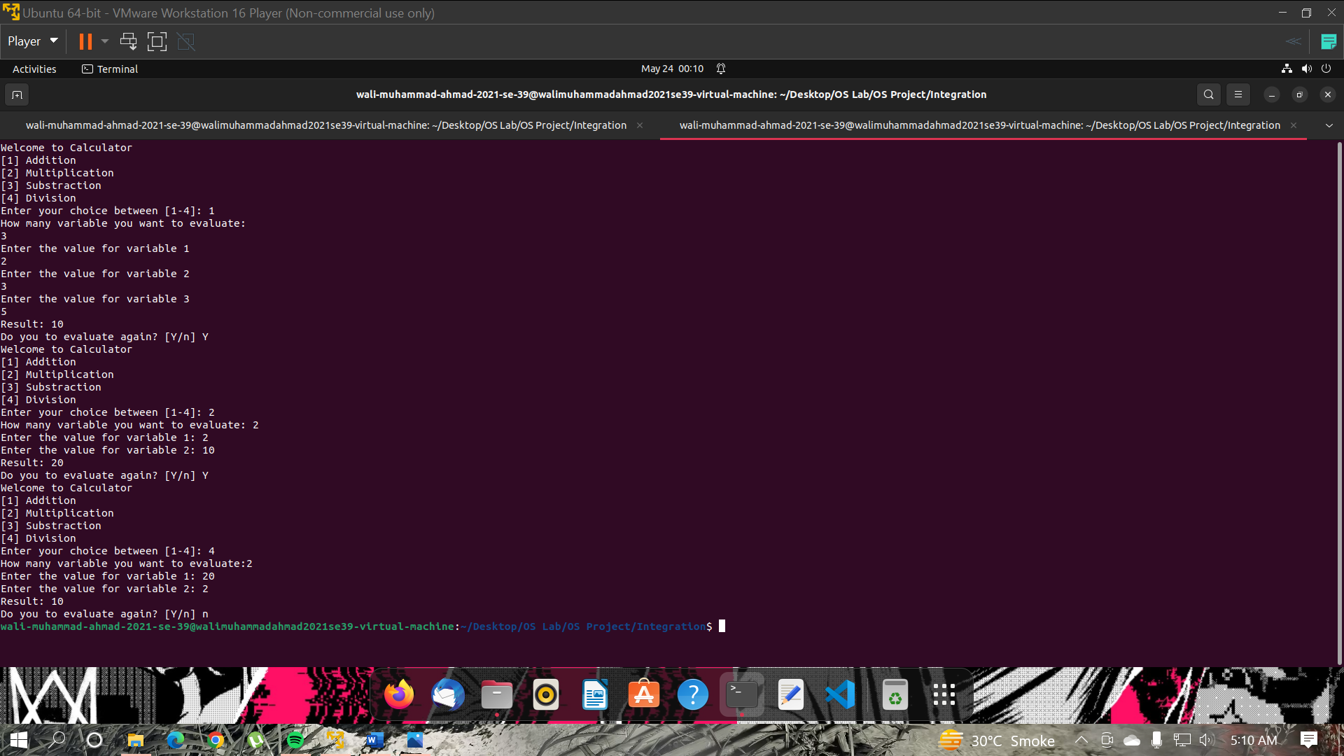

1. **Hangman Game**

The Hangman Gameplay is shown in the screenshot provided. User only have to guess the word and enter the words in the form of letters. The results will show individually foe every input. If the user failed to guess the word in 10 attempts the game will be over.

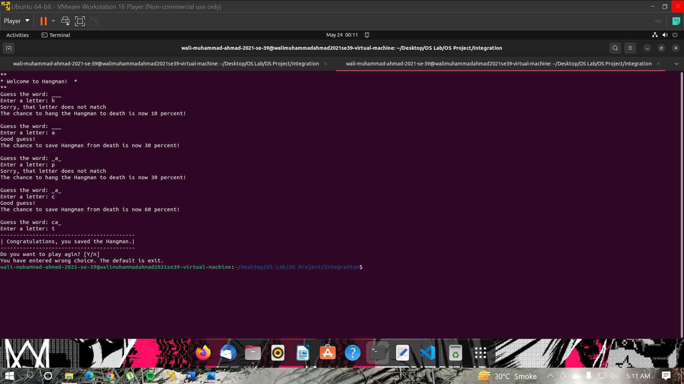

1. **Snake Game**

The Hangman Gameplay is shown in the screenshots below:

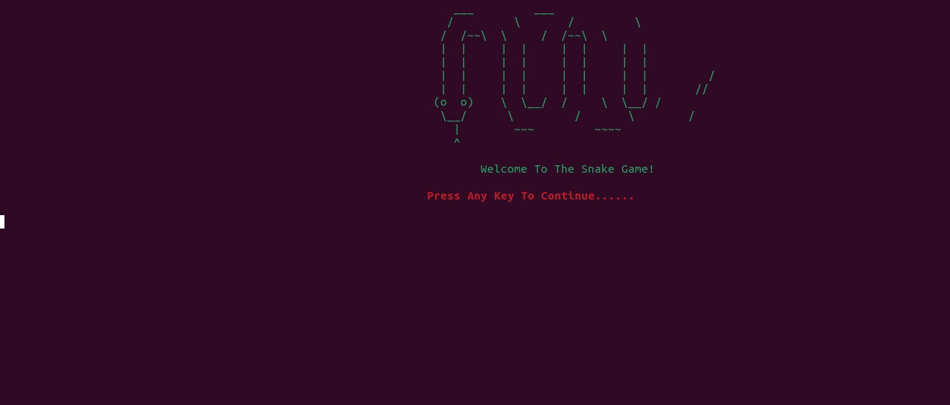

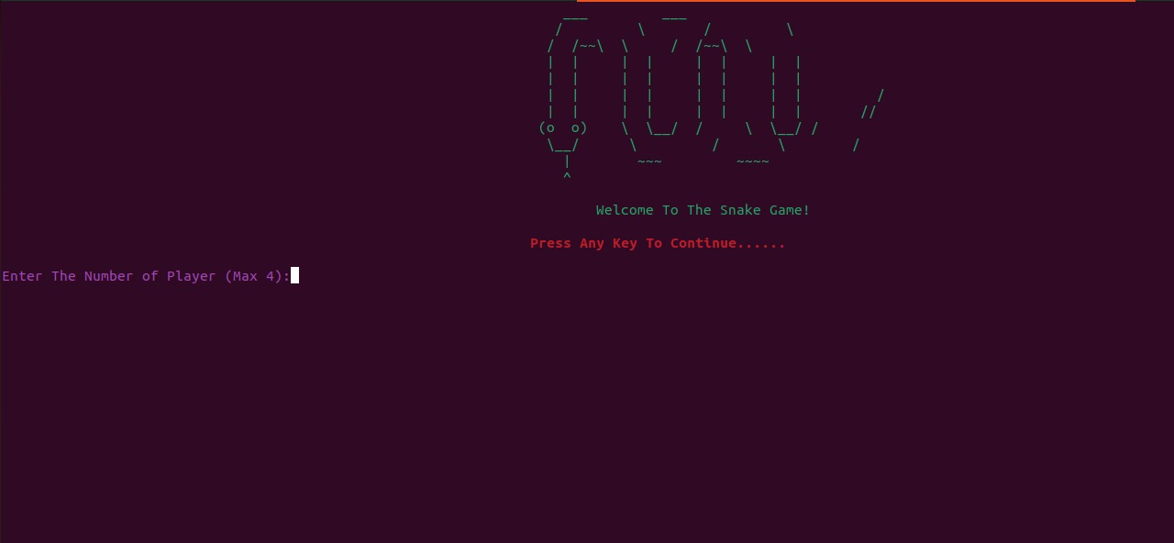

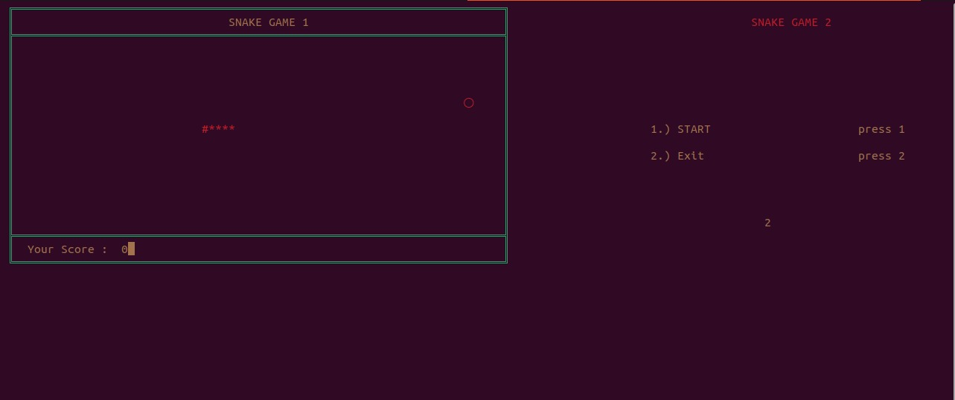

1. **Huffman Encryption & Decryption**

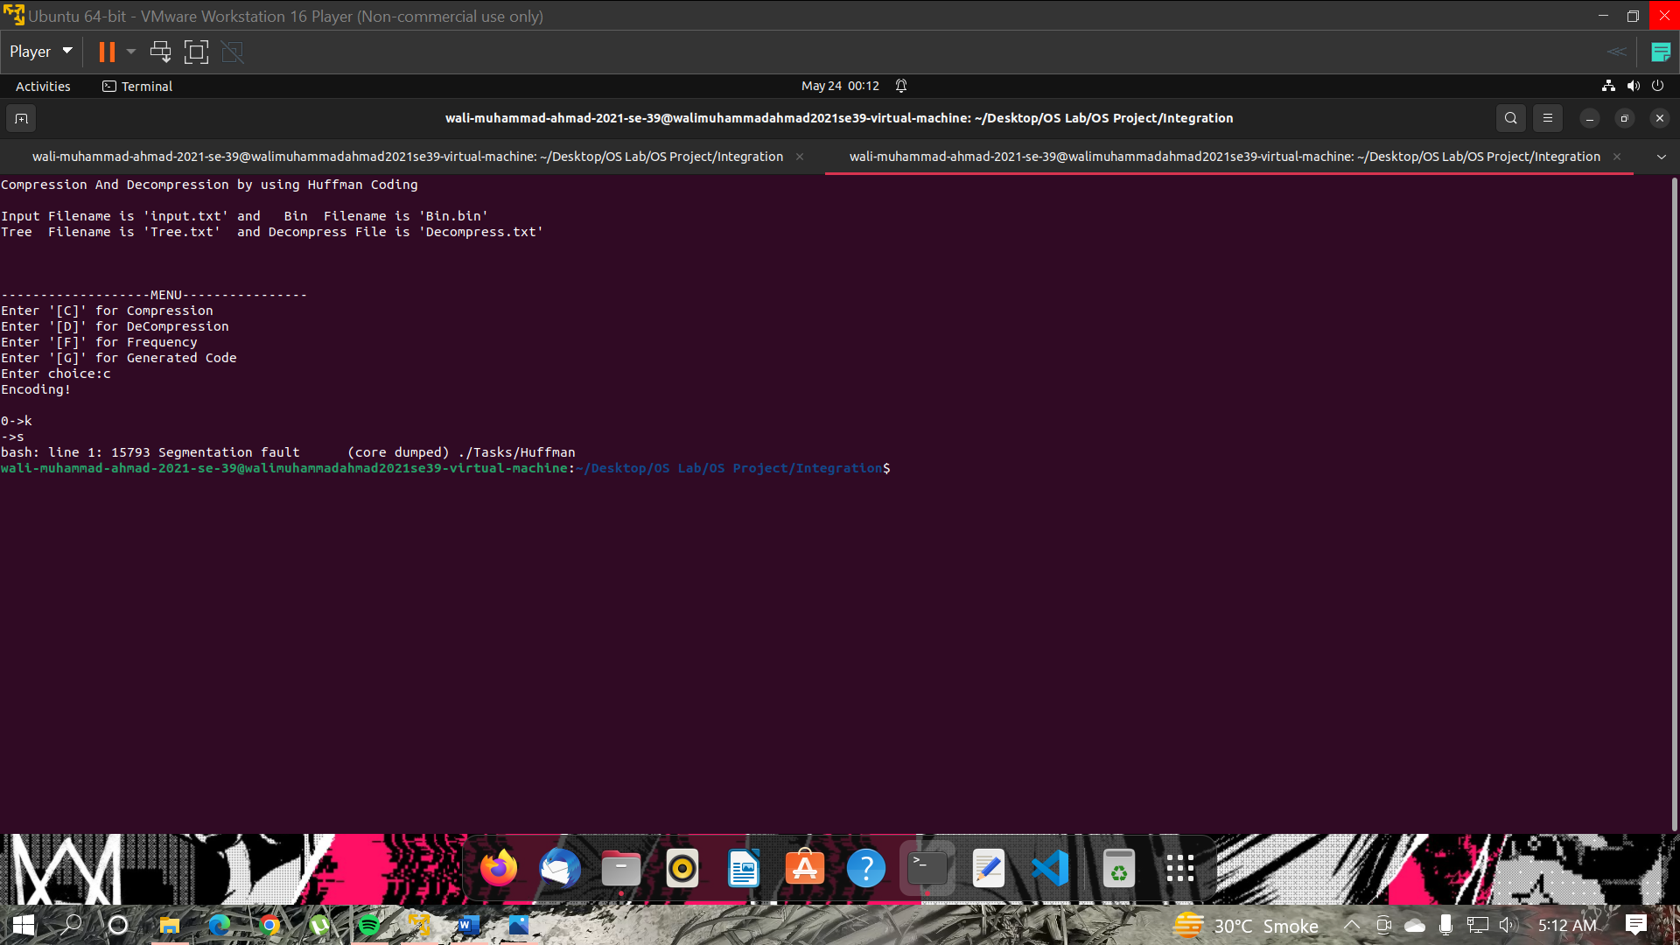

1. **Simple CLI**

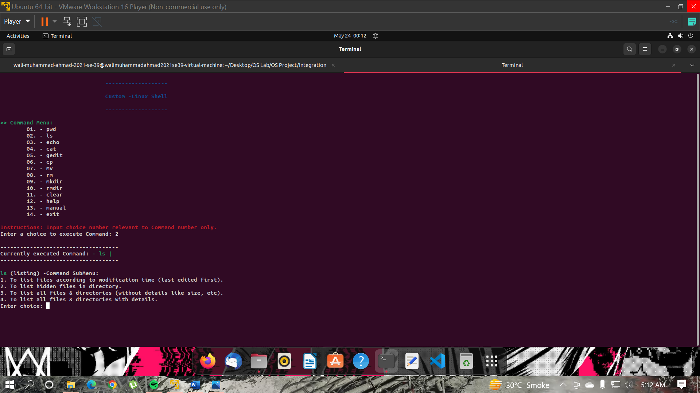

1. **Currency Converter**

The method to use Currency Converter is shown in the screenshot provided. The user only have to enter option to select the currency and then enter the amount in PKR.

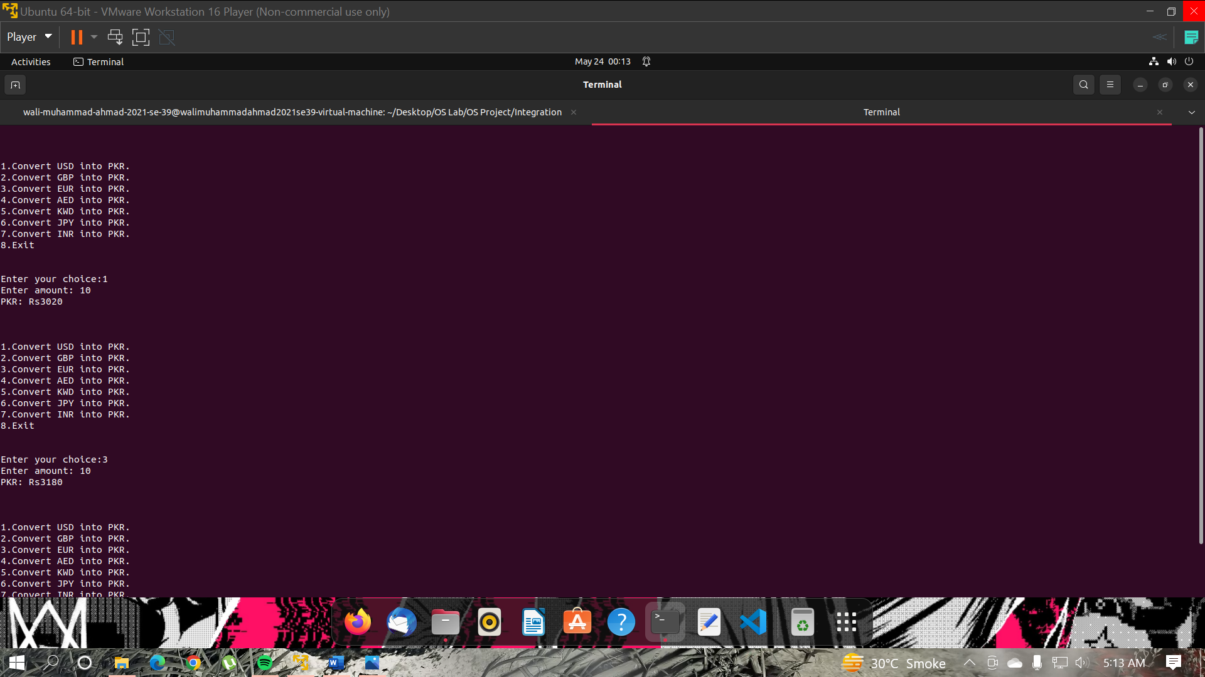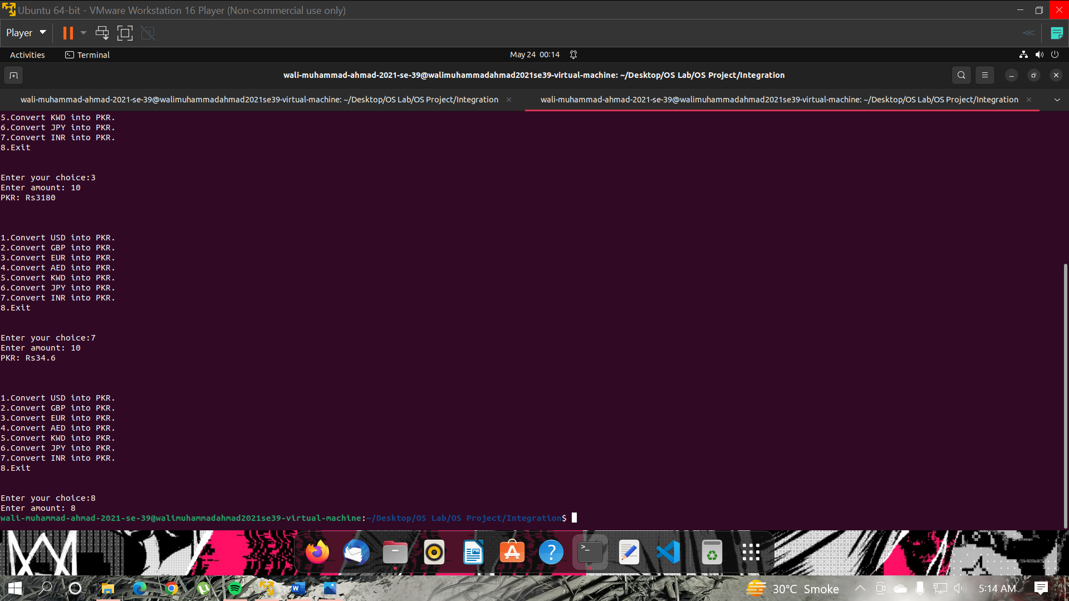

1. **Exit(Power off)**

The “Exit (Power Off)” option will terminate all the parallel running tasks and shutdowns the system. A shutdown screen will be shown in the terminal.

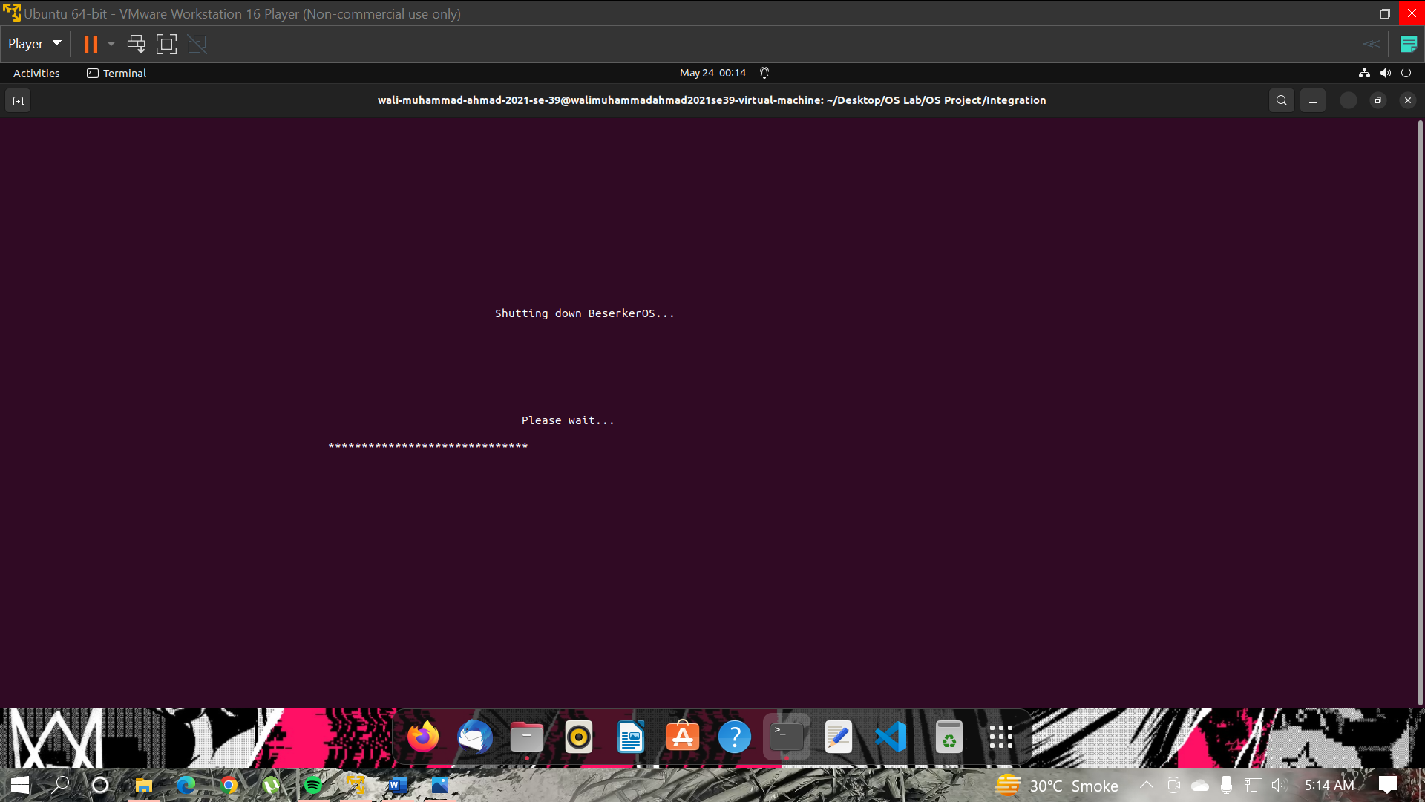

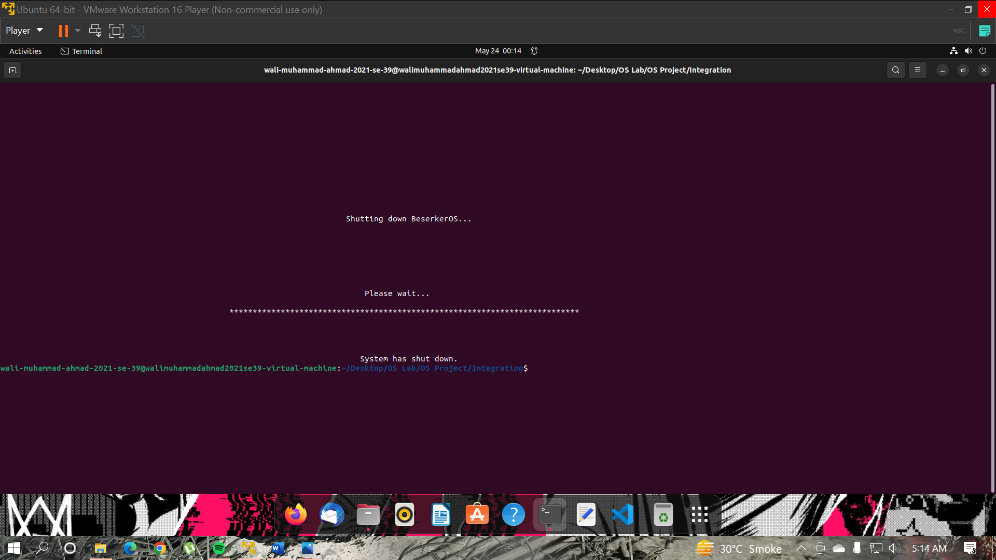

1. **Concepts Used**

We have used all of the concepts taught us in the class room and labs to implement this Simulator. The concepts used are shown below:

1. **Command line parameter passing**
2. **Process Creation using Fork()**
3. **EXEC function**
4. **Threading**
5. **Resource allocation**

**______ The End ______**